Instructions: Prepare and submit a document describing the visualizations and how the dashboard (or story points) lead to some finding(s). To facilitate your descriptions include screenshots or copies of the visualizations.

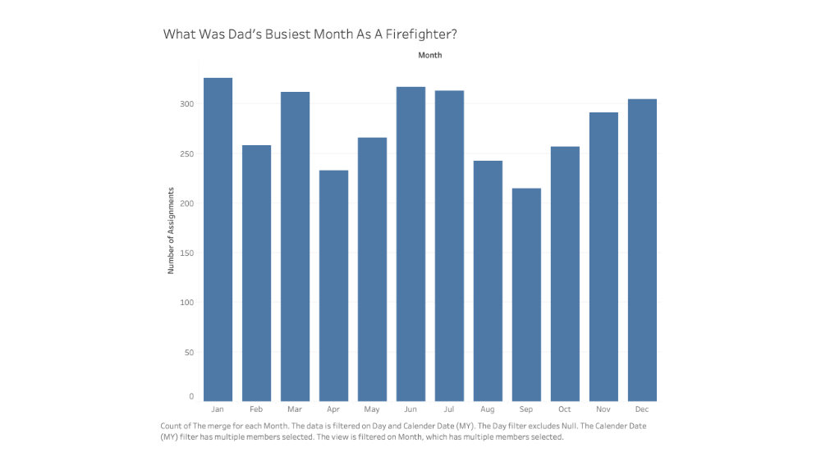

- The purpose of this slide was to find out what months’ dad was busiest as a firefighter. We found that he was busiest in January, June, July, March, and December.

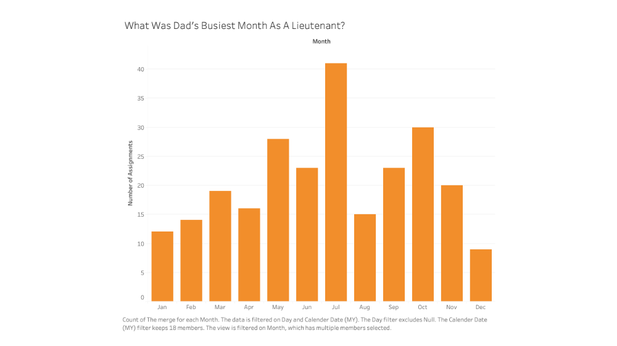

- This slide found what month dad was busiest as a Lt. He was very busy in the month of July.

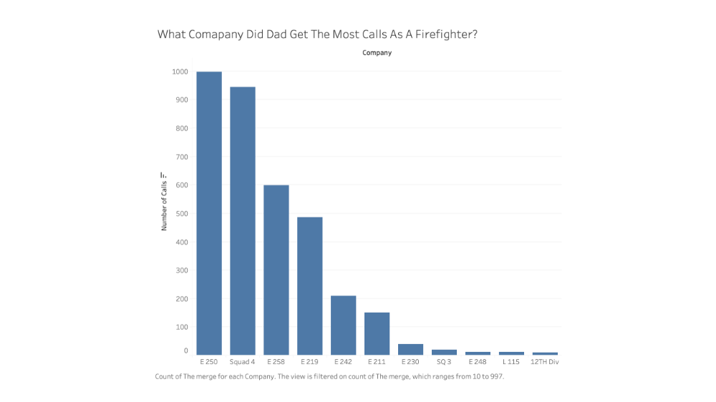

- This slide showed us what company dad was busiest in when he was a firefighter. E 250 and Squad 4 were the two busiest companies.

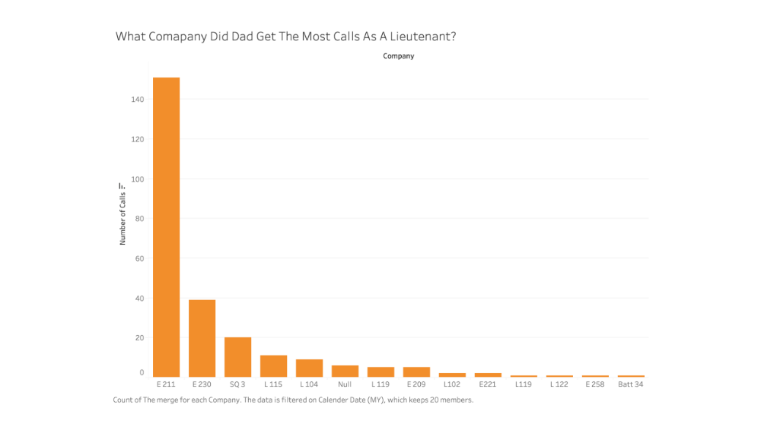

- This slide showed us what company dad was busiest in when he was a Lt. E 211 was his busiest company by a lot

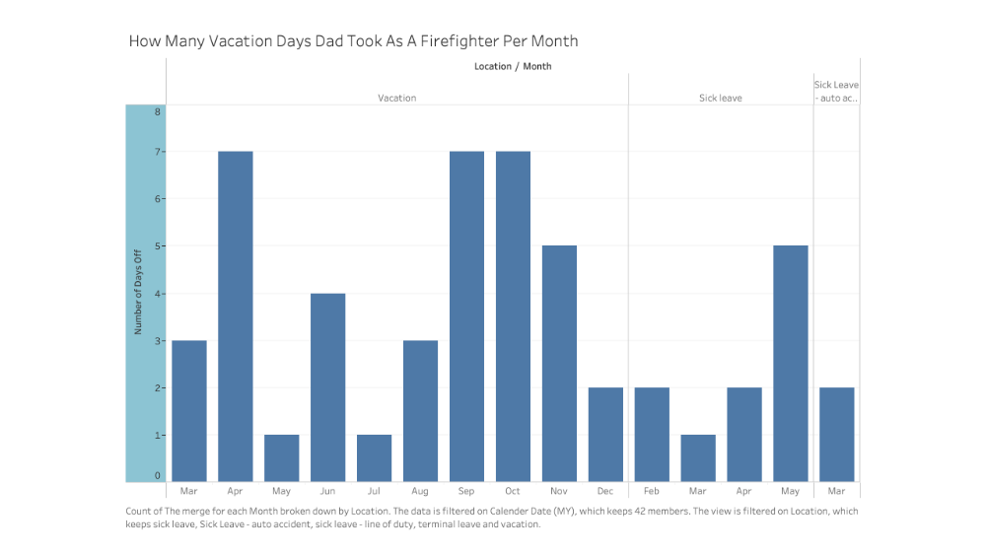

- The goal was to see what months dad took the most days off as when he was a firefighter. September, October, April, and May stand out.

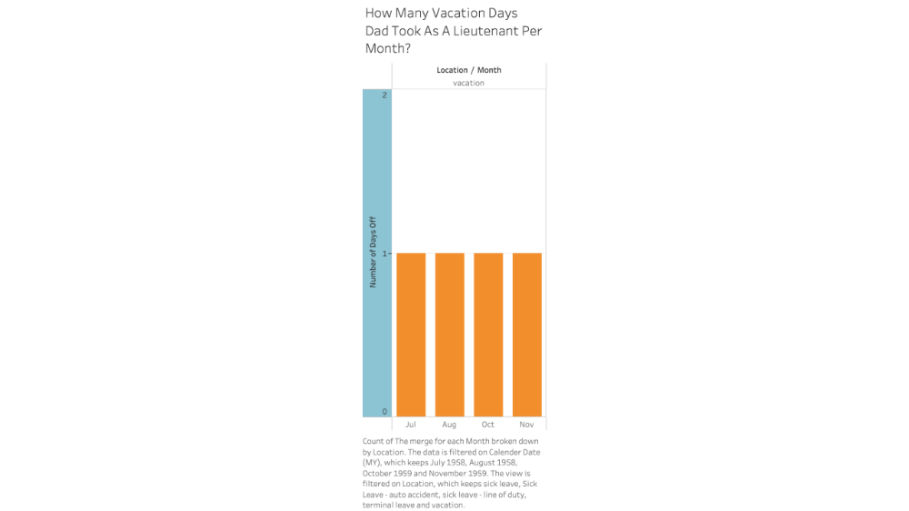

- The goal was to see what months dad took the most days off as when he was a Lt. He did not take much time off as a Lt.

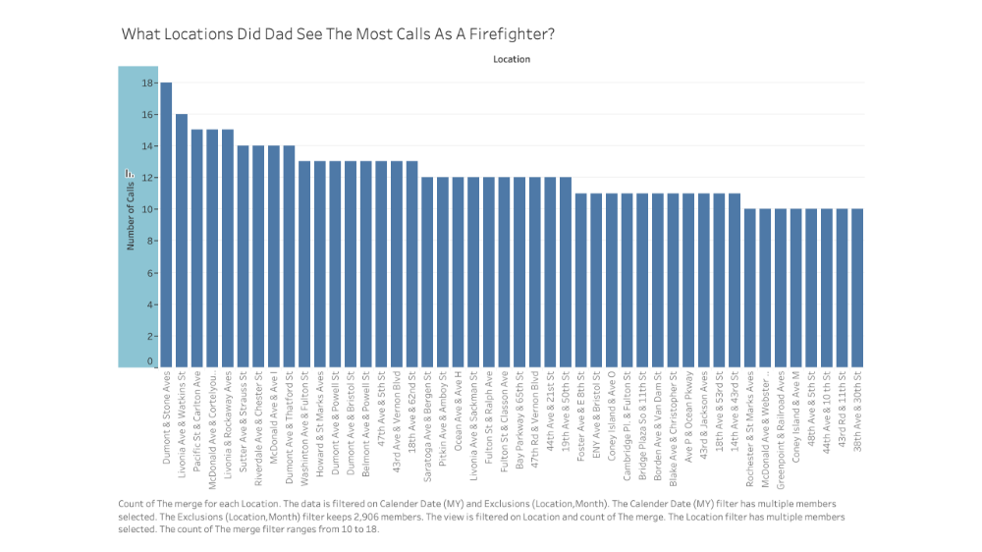

- The purpose of this slide is to find out what locations dad frequented at as a firefighter.

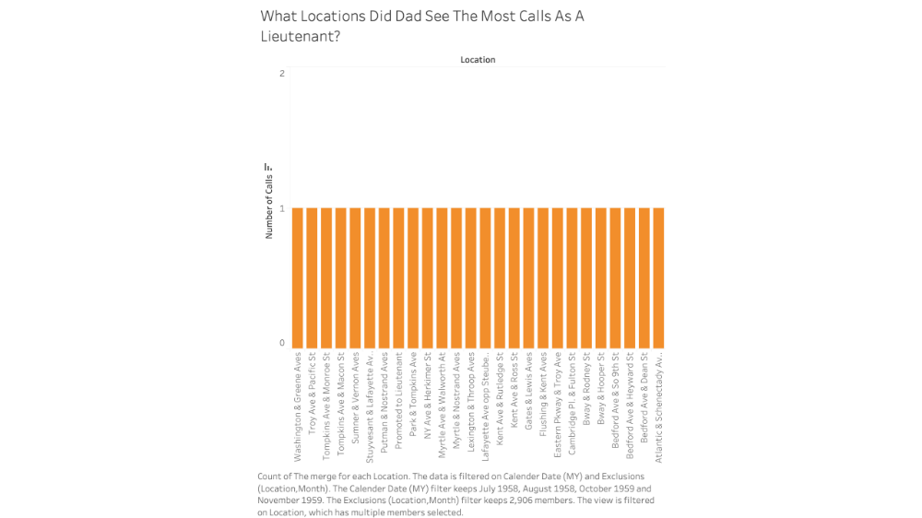

- The purpose of this slide is to find out what locations dad frequented at as a Lt.

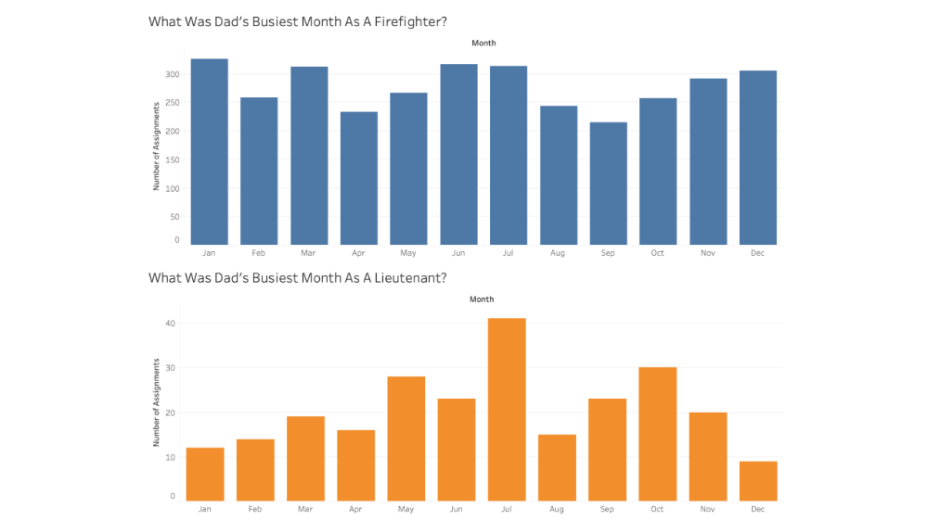

- This dashboard compares how busy each month was as a firefighter vs a Lieutenant.

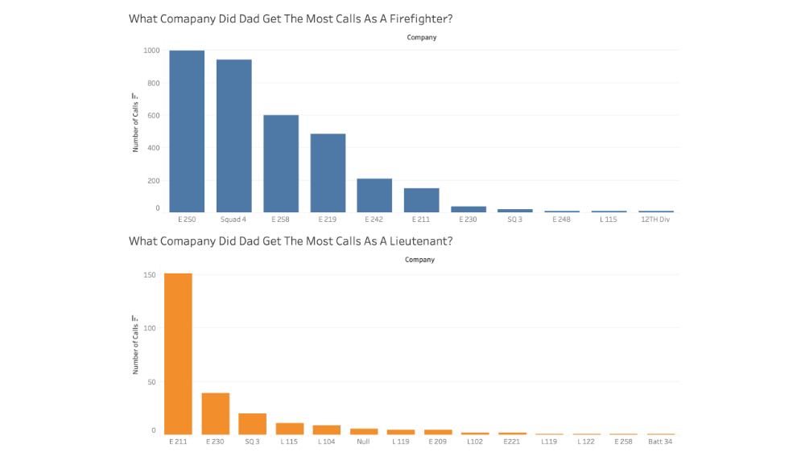

- - This dashboard compares how busy each comapny was as a firefighter vs a Lieutenant.

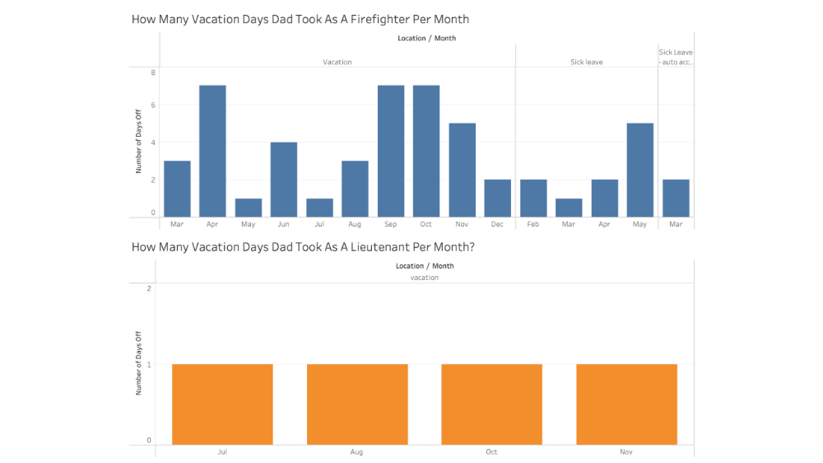

- This dashboard compares how much time off dad got when he was a firefighter vs a Lieutenant.

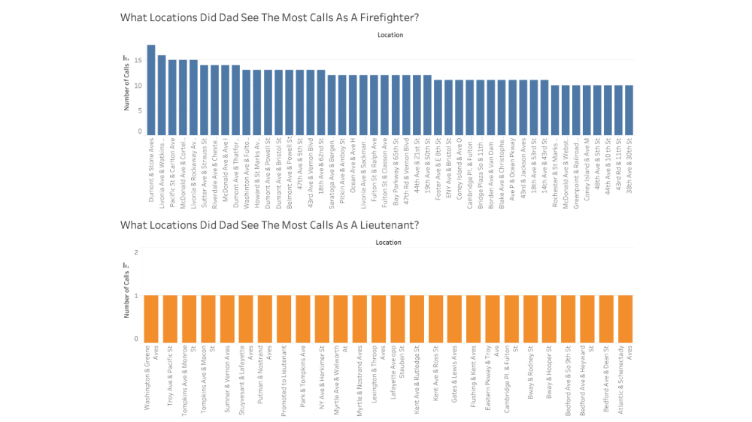
- This dashboard compares what locations dad frequented at when he was as a firefighter vs as a Lieutenant.

